1: Motherboard model number – GA-H81M-S2PV

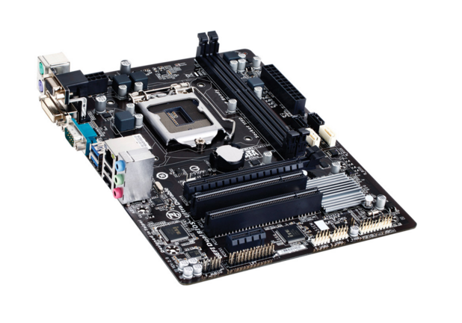

CPU Socket

Ram Slots

2: Supports 4th Generation Intel® Core™ processors

* GIGABYTE Ultra Durable™ 4 Plus Technology
* GIGABYTE UEFI DualBIOS™
* GIGABYTE On/Off Charge™ for USB devices
* LAN with high ESD Protection
* DVI-D, D-SUB, COM port on rear panel
* All solid capacitors design
* Intel® H81 Express Chipset

RAM

* 2 x DDR3 DIMM sockets supporting up to 16 GB of system memory Dual channel memory architecture

Audio

* Realtek® ALC887 codec
* High Definition Audio
* 2/4/5.1/7.1-channel